☺  prep.school  ☺ Subject : English  ☺ Duration : 1 hour   | ☺ Teacher :  ☺ Class : 8th form  ☺ Mid- term test N : 1  2021-2022
Name : --------------------------------------------------------------------------------------- . N: --------------------------------- .
I-Listening comprehension ( ---- / 8 marks )
Note
………… / 20


- Tick he right alternative: (2 marks)
- Howard is talking about his: winter vacation
Spring break
Summer vacation
- He went to: California
Hawaii
Florida
- How long was Howard’s stay? (1 mark)
………………………………………………………………………………………….
- What was the weather like? (1 mark)
………………………………………………………………………………………………..
- Who did Howard visit? (1mark)
………………………………………………………………………………………………..
- Circle the correct function of the following utterance: (1 mark)
"It was wonderful. The weather was warm every day. It was sunny every day and the temperature was almost 80 degrees."
Talking about daily routines / Inviting/ Describing

- Listen and circle the words you hear: (1 mark)
I came (tack / back) home and read a (book / cook).
- Listen and complete with TWO words from the passage: (1 mark)
I had a …………………………….. time. I saw a couple of new movies. I saw The Aviator and also an …………………………….. movie called Spanglish.
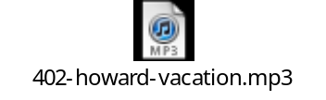

II -Language ( ---/ 12 marks )

Supply the right tense or form of the bracketed words. (---/ 3.5 marks) Dear Linda,
Here I am in sunny Jerba. I’m having a lovely time. Every day, I (get up) ………………. Very early and do some exercise to keep fit. The weather is hot and sunny. At the moment, I (sit) …………………on the sandy beach with my husband, Joe. I like (sunbathe) ………………..very much. Yesterday, we (go) ……………. windsurfing. We had a great time. Then we went to a traditional restaurant in the oasis and (eat) ……………smoked fish. It’s really delicious. Life here is fantastic. I really want to enjoy it to the full before (go) ………………. back to London. We’ve been here for three days now and we’re planning to stay for the rest of the week because we’re enjoying ourselves so much. By the way, we (leave) ……………….. Jerba next Monday.
I’m looking forward to seeing you when we come home.
See you then.

Love, Amy
Complete the letter with the right options in the box ( ---- / 3 marks)
1- came / will come / comes 4- Books / money / clothes
2- decide / decisive / decision 5- unable / improve / able
3- stairs / weather / school 6- quiet / wonderful / happy

Dear Sonia,
I received your letter yesterday. I am happy that you (1) -------------------- to Boston next holidays. I think you made a good (2) --------------------- . I am sure you will enjoy your holidays very much. Boston is different from London. It’s usually nice and sunny here . But in Winter the (3) ------------------------ is very cold. So you will need only winter (4) ------------------------. You will be (5) ------------------------ to see many (6) ------------------------ places and beautiful sights . I’m sure you‘ll enjoy your stay .
write soon . 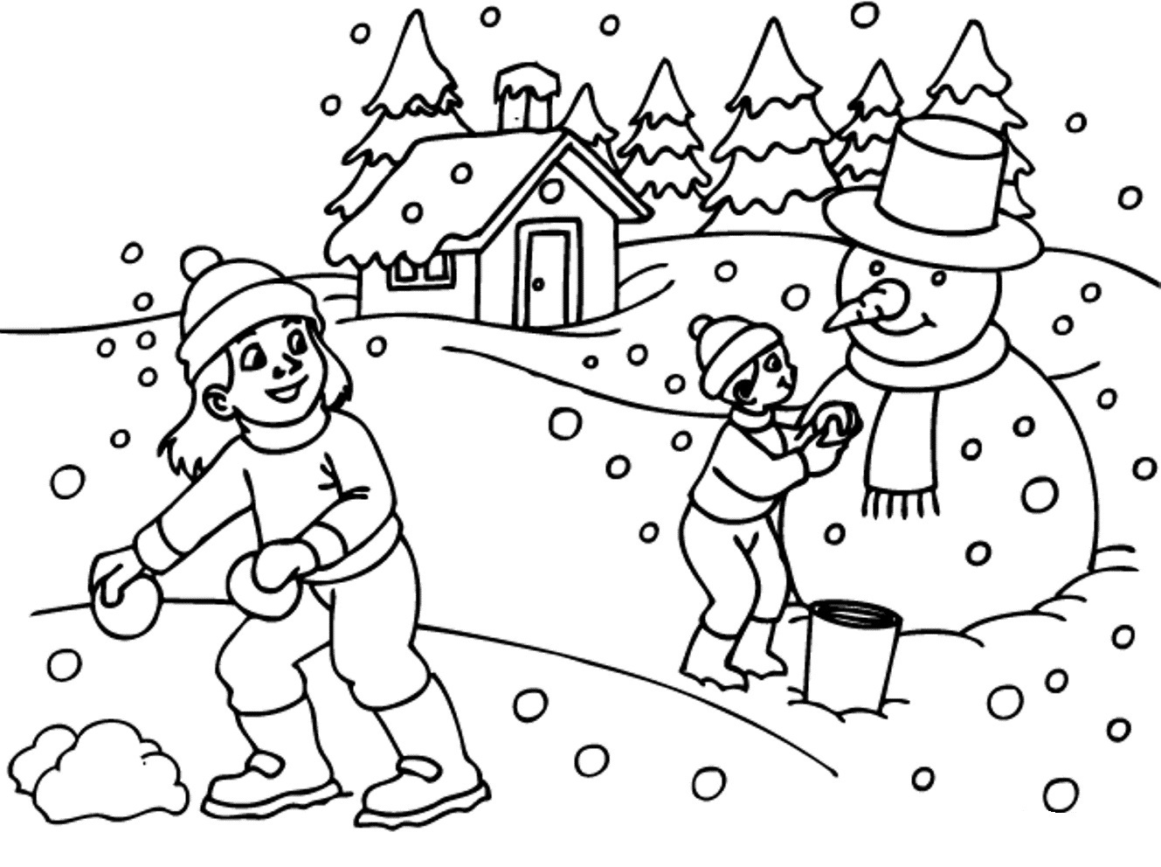 Sandra


Circle the correct alternative: (2.5 marks)

These are the Browns. They are from England. Mr Brown is a (bake/ baker/ bakery). He bakes bread in his big (bakery/ shop/ house) in London. His wife is a shopkeeper. She sells fresh bread and cakes. The Browns have two wonderful (child/ friends/ children): Christopher and Christine. Christopher is 14. He is older than his (sister/ brother/ daughter). The Browns were in Jerba last month. They liked Jerba because it is calm and (peace/ peaceful/ busy). In Jerba, Chris became friends with Imene Najjar and invited her to visit him in London.



A | B | C
Peter: (1)Would you like to attend my birthday party ? | A- Ability in the future | 1+ ---
Tom :(2)Yes, of course . (3) Thank you ! | B- Refusing | 2+ ---
Peter : What about you Sarah? | C-Asking about time. | 3+ ---
Sarah :(4) sorry, I cannot. I should help my mother. | D-Accepting | 4+ ---
Peter : O.K then (5) you will be able to come next year. | E- Inviting | 5+ ---
Tom : (6) when shall I come ?  Peter : on Saturday .I’m sure we will have fun ! | f- Greeting. | 6 + ---
 | H – Thanking.
Match the statements in (A) with their functions in (B).
There is 1 extra function. (---- / 3 marks)

Good work J


The script:
OK, now I'll talk about my winter vacation. This winter vacation I spent two weeks in my hometown which is Daytona Beach, Florida. It was wonderful. The weather was warm every day. It was sunny every day and the temperature was almost 80 degrees. I visited my mother and I spent every morning having a nice leisurely cup of coffee and reading the newspaper and after that I got my bicycle out and and rode down to the beach and enjoyed the sun and the surf, ah, came back home and read a book and went to bed early.
I had a wonderful time. I saw a couple of new movies, when I was home in Florida. I saw The Aviator and also an interesting movie called Spanglish, which I hope you all can see because it's an interesting movie about English and Spanish.

